Making the story for the Cervical Screening Paper – 2nd June 26

Abstract
Infection with Human Papillomaviruses (HPV) is a necessary cause of cervical cancer. England has vaccinated girls aged 12-13yrs against HPV since 2008: the oldest of this vaccine-eligible cohort are now screened. The current strategy invites all people with cervix to 5-yearly screening from age 25 (8 Lifetime Screens; LS), but this screening algorithm needs updating to incorporate vaccinations status. Using the Agent-Based Model HPVsim, validated to recent English data, we assess different screening frequencies according to individual (i) vaccine-eligibility, and (ii) vaccination status. We project cancer incidence rate per 100k and long-term undiagnosed cancer prevalence (LUDP) to 2050 in England.

We show that it remains necessary to screen all individuals, however screening frequencies can be reduced from 8 to 6 LS for unvaccinated vaccine-eligible and to 4 LS for vaccinated individuals, to keep projected incidence in line with the current policy.

- Projecting at 80\% vaccine coverage, a reduction from 8 to 4 LS in HPV-vaccinated/vaccine-eligible women leads to negligible population-level change in mean projected cervical cancer incidence rate (8LS: 2.6; 4LS: 2.7 / 2.8, 2050).

- Screening according to vaccine-eligibility leads to greater inequity with higher cancer incidence rate for the unvaccinated vaccine-eligible as screening frequency decreases (8/6/4 LS: 0.9/1.3/1.7, 2050). In contrast, a screening reduction for vaccinated individuals from 8 to 4 LS has negligible impact on incidence amongst the vaccinated (8/6/4 LS: 0.1/0.2/0.2, 2050), but incidence increases at lower screening frequencies (3LS: 0.4, 2050).

- While a reduction in vaccine uptake to 60\% will require more total screening for unvaccinated people across the population, individual lifetime screens can remain at 6 LS for the unvaccinated vaccine eligible and 4 for the vaccinated to retain current incidence rate projections.

- Under the current English screening policy, population-level cervical cancer elimination is unlikely by 2040, more likely by 2045, and very likely by 2050 (elimination probabilities 22\%; 75\%; 98\%).

As increasing numbers of HPV-vaccinated individuals become eligible for cervical screening, our work demonstrates the importance of taking vaccination status into consideration when designing cervical cancer screening strategies. We showcase a novel application of a complex Agent Based Model as a tool for evaluating personalised healthcare strategies at a national level.

Detail for RESULT 1
“Projecting at 80\% vaccine coverage, a reduction from 8 to 4 LS in HPV-vaccinated/vaccine-eligible women leads to negligible population-level change in incidence rate of cervical cancer (<1\% / 3\% median incidence increase 8LS: X; 4LS: Y1/Y2, 2050).”
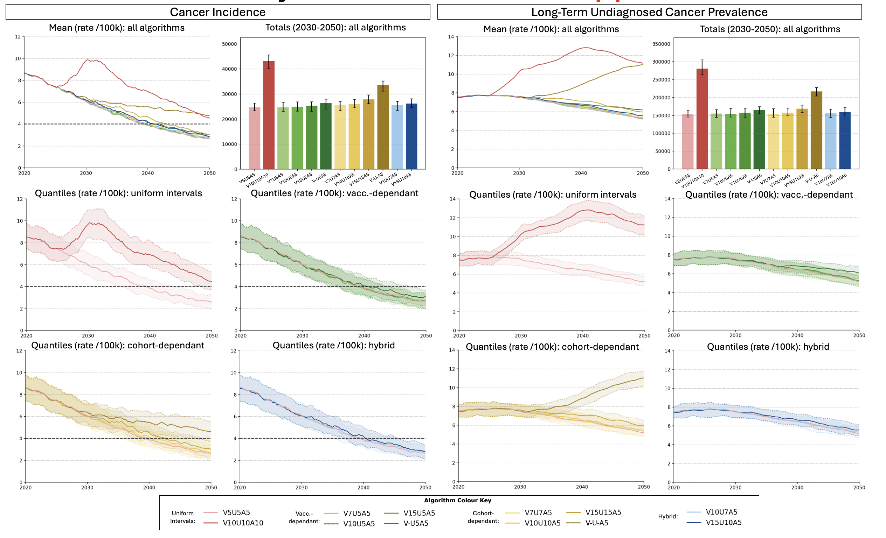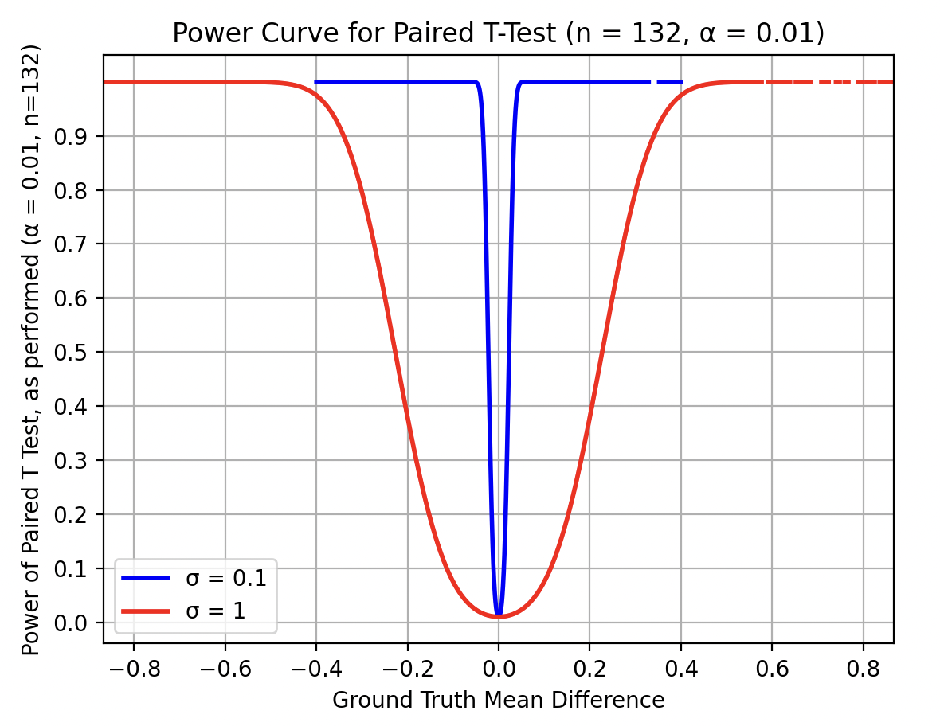
We project cancer incidence and ‘long-term of undiagnosed cancer prevalence’ (LTUP) (i.e. cervical cancer which has not been diagnosed through screening and has existed for at least 5 years) as rates (/100k), assuming 80\% vaccine coverage (Figure X). We perform paired t-tests between scenario simulations (pairing on simulation conditions up to introduction of alternative screening), with a p-value cutoff of 0.01 for significance. This test has >80\% power for detecting changes >=0.3 in mean cancer incidence rate and >=1 in mean LTUC rate. When differences are significant, we report Cohen’s d for effect size. Unless otherwise specified, statistical tests are against a baseline projection of continuation of current screening (V5U5A5).

On a population-wise level, all but two modelled algorithms lead to similar incidence results; these exceptions are 10-yearly screening for all (V10U10A10) and the elimination of screening for vaccine-eligible individual, even when retaining current screening for the vaccine-ineligible subpopulation (V-U-A5). Inherent stochasticity of Agent-Based Modelling captures high aleatoric uncertainty in cancer outcomes.
Comparison of screening algorithms in terms of either cancer incidence or LTUP yield consistent patterns: with everything other than screening kept constant, population-wise cancer outcomes 2030-50 is most heavily influenced by screening frequency in the older vaccine-ineligible population. A uniform reduction from 5 to 10-yearly screening increases incidence in 2040 from 3.9 to 7.0 (p<.001; d=3.09), and LTUP from 26 to 51 (p<.001; d=4.55) in 2040. In contrast, restricting such a screening frequency reduction to vaccinated/vaccine-eligible individuals yields much milder changes with incidence 4.0/4.2 (p=.11/<.001 ; d=-/0.38) and LTUP 26/26 (p=.68/.15) in 2040.

Targeted reduction of screening frequency for vaccinated individuals up to 15-yearly screening has minimal population-level impact. Reduction to from 5- to 7/10/15-yearly screening for the vaccinated increases mean projected population level incidence rates from 3.9 to 3.9/4.0/4.0 (p=.25/.12/.45) in 2040 and 2.6 to 2.7/2.7/2.7 in 2050 (p=.40/.38/<.001; d=-/-/0.18). Corresponding LTUP rates show no significant change in (p=0.07/0.68/0.30) 2040 and 2050 (p=0.60/0.75/0.73), with values 26/100k and 21/100k for all algorithms, respectively. The elimination of routine screening for vaccinated individuals, however, causes worsening of population-cancer outcomes with increasing effect size over time: cancer incidence rate of 4.1 in 2040 (p<.001; d=0.34), and 3.1 in 2050 (p<.001; d=0.58), and LUDP of 27 in 2040 (p<.001; d=0.40) and 25 in 2050 (p<.001; d=0.84).

Reduction of screening frequency for all vaccine-eligible individuals down to 10-yearly has little population-level impact; reductions beyond this cause increases in cancer incidence and LTUP which are notable at the population-level. Screening frequencies of 7-/10-/15-years/never yield mean incidence rates 4.0/4.2/4.7/5.6 in 2040 (p=.11/<.001/<.001/<.001 ; d=-/0.38/0.98/1.98) and 2.7/2.8/3.0/4.8 in 2050 (p=.27/.01/<.001/<.001 ; d=-/0.22/0.56/2.06). Corresponding LUDP increases to 26/26/28/35 in 2040 (p=.67/.15/<.001/<.001 ; d=-/-/0.74/2.05) and 22/22/24/44 in 2050 (p=.03/<.001/<.001/<.001 ; d=-/0.32/0.82/3.34).

10- and 15-yearly screening of vaccinated individuals can be augmented with 7- and 10- yearly screening of unvaccinated vaccine-eligible individuals respectively without substantial changes in population-level cancer outcome. V10U7A5/V15U10A5 yield incidence rate 4.01/4.20 in 2040 (p=.52/<.001; d=-/0.35) and 2.78/2.85 in 2050 (p=.08/.06) (comparing to V10U5A5 and V15U5A5 respectively). Corresponding LUDP is 26/27 in 2040 (p=.02/.10) and 21/22 in 2050 (p=.08/<.001; d=-/0.39).

V10

Hybrid screening intervals can yield equivalent incidence to corresponding vaccination-wise intervals, while permitting a lower screening burden. V10U7A5 yields incidence rate X/X and screening reduction of X/X \% in 2040/50; cancer incidence is not significantly different to V10U5A5 (p=.52/.08), V7U5A5 (p=.30/.08), or V7U7A5 (p=.41/.20), and significantly better than V10U10A5 in the short term (p<.001/=0.82; d=0.24/-).However, V15U10A5 yields incidence rate X/X and screening reduction of X/X \% in 2050; which, while not yielding significantly different cancer incidence to V10U10A5 (p=.90/.09), yields significantly worse cancer incidence than V15U5A5 in the short term (p<.001/=.06; d=0.35/-).

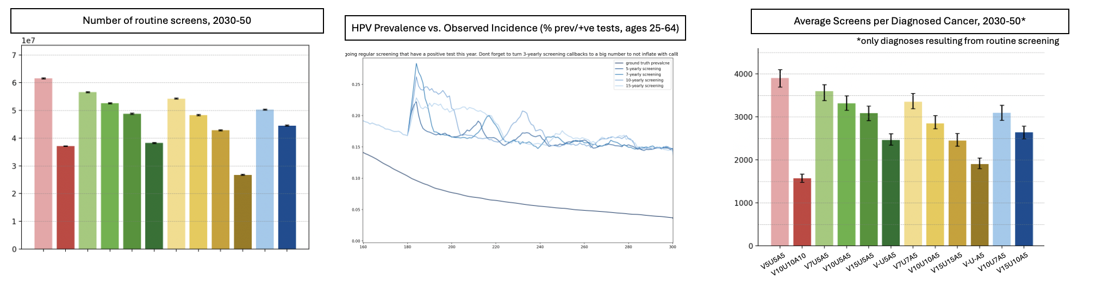

Uses of these figures that need to be clarified in discussion:
- Screening is also used for surveillance, so it is important to see how lower frequences affect this. Though I suppose it would probably just be a matter of proportionally lower observed HPV incidence for each subpopulation, but I suppose a simulation to verify that doesn’t hurt?
- Screening does not just impact incidence (though critically it does impact incidence because it can catch CIN and treat with ablation before they develop into cancer, as well as identifying those who are HPV +ve to then screen them more frequently – and this behaviour I do not change as at the point of being identifies as HPV +ve it seems unreasonable to treat people differently depending on vaccine-status and definitely unreasonable depending just on vaccine-eligiblity). In fact, for those who do have cancer, lower screening will mean longer time to diagnosis. Therefore tracking undiagnosed cancer prevalence is important – and long-term undiagnosed cancer prevalence is being tracked as proxy for cancers which have been able to develop for long enough to be a later stage (which is associated with signficiantly worse prognoses).
  - This also requires proper statistical testing between screening algorithms in terms of this metric, therefore
  - Of course, if it turns out the relative patterns /relationships between different screening algorithms are the same for both ludp and incidence, then I can continue to use incidence throughout and don’t need to both much about this other than at this one section in order to make that argument that the two metrics agree in terms of the best screening algorithm
  - In that case, I think Long term undiagnosed cancer prevalcne could be taken away from the equity analysis as it adds potentially unnecessary detail; instead lets look at these alternative metrics here (also considering subpopulations iff needed, and if it does turn out to be needed then we will do the first equity analysis and then to the alternative metrics underneath it with the equity analysis immediately ‘built in’ instead)
- Screens/diagnosis is a metric closely related to health economics and therefore an important one to include for that

Detail for RESULT 2
“Screening according to vaccine-eligibility leads to greater inequity with worse outcomes for the unvaccinated vaccine-eligible as screening frequency decreases (incidence rate 8/6/4 LS: 0.9/1.3/1.7 2050). In contrast, a screening reduction for vaccinated individuals from 8 to 4 LS has negligible impact amongst the vaccinated (8/6/4 LS: 0.1/0.2/0.2 incidence rate 2050), but incidence increases at lower screening frequencies (3LS: 0.4 incidence rate 2050).”

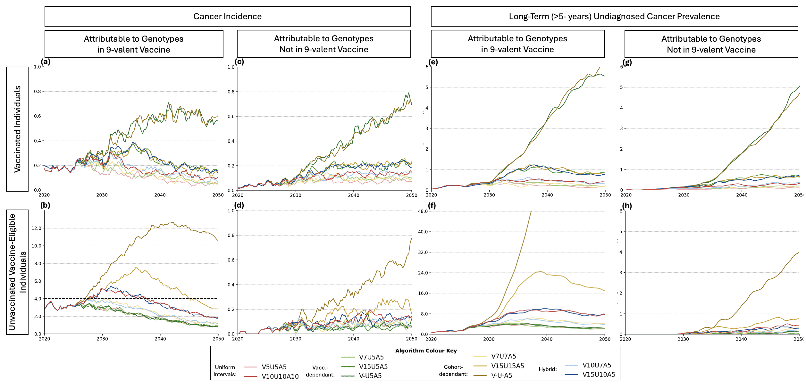

- But do not forget to look for the t values and interpret using cohen’s d as clearly some effect sizes are larger than others even when significant! https://www.statology.org/interpret-cohens-d/

We perform a subpopulation analysis,

Detail for RESULT 3
“While a reduction in vaccine uptake to 60\% will require more total screening for unvaccinated people across the population, individual lifetime screens can remain at 6 LS for the unvaccinated vaccine eligible and 4 for the vaccinated to retain current incidence rate projections.”

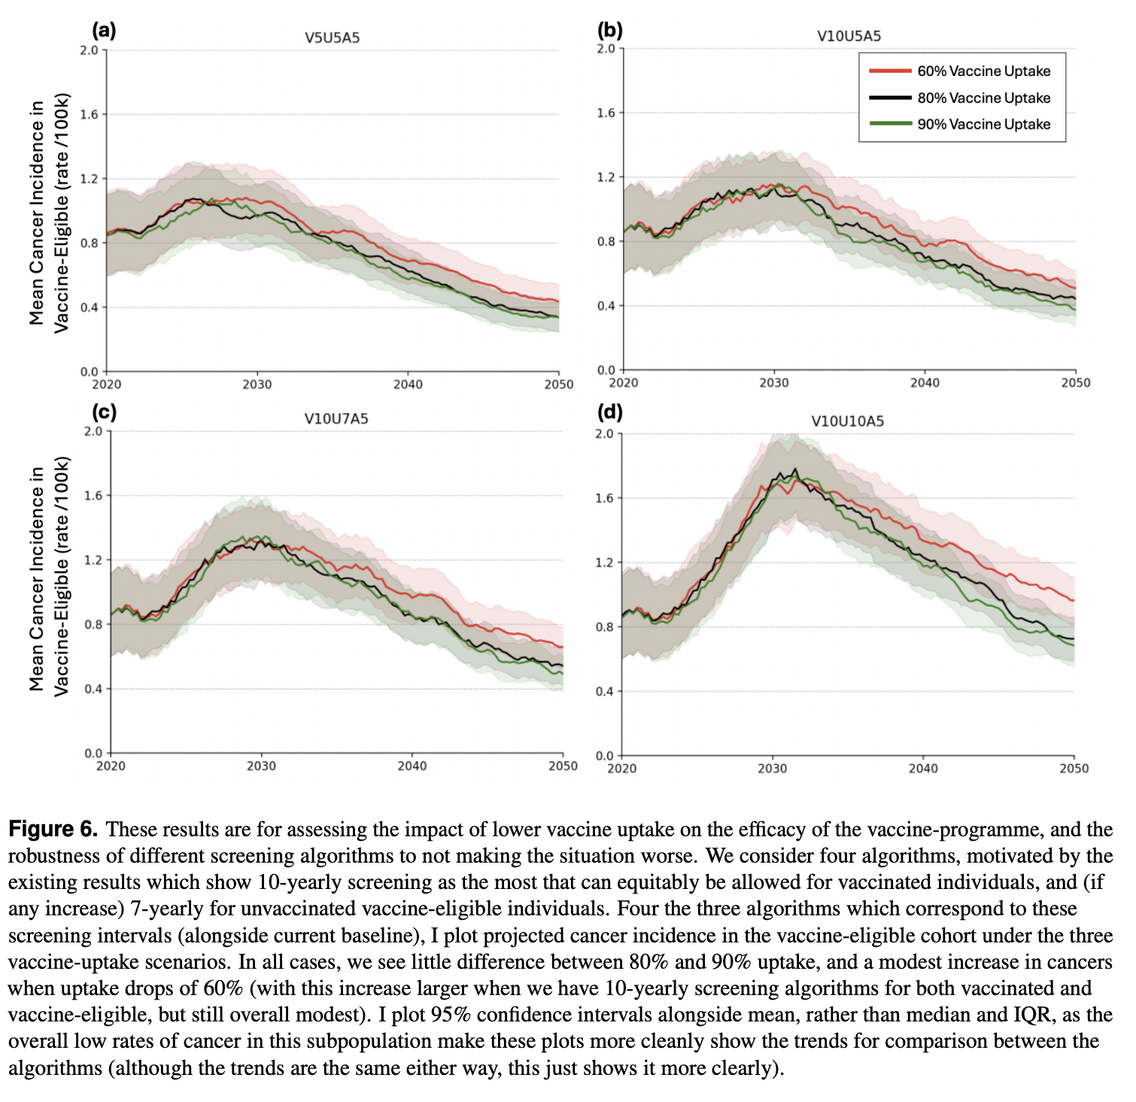
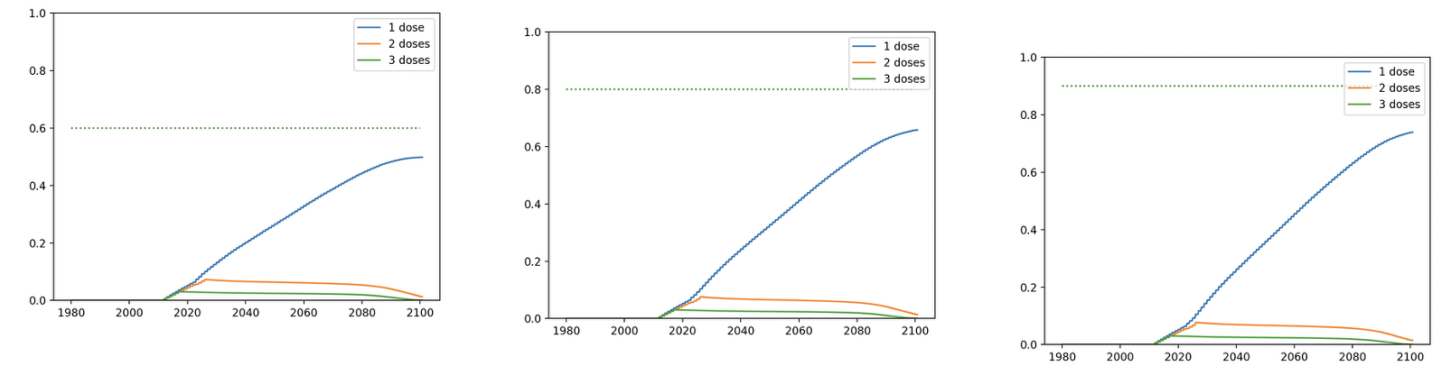

Detail for RESULT 4
“Under the current English screening policy, population-level cervical cancer elimination is unlikely by 2040 (elimination probability 22\%), more likely by 2045 (elimination probability 75\%) and very likely by 2050 (X)”
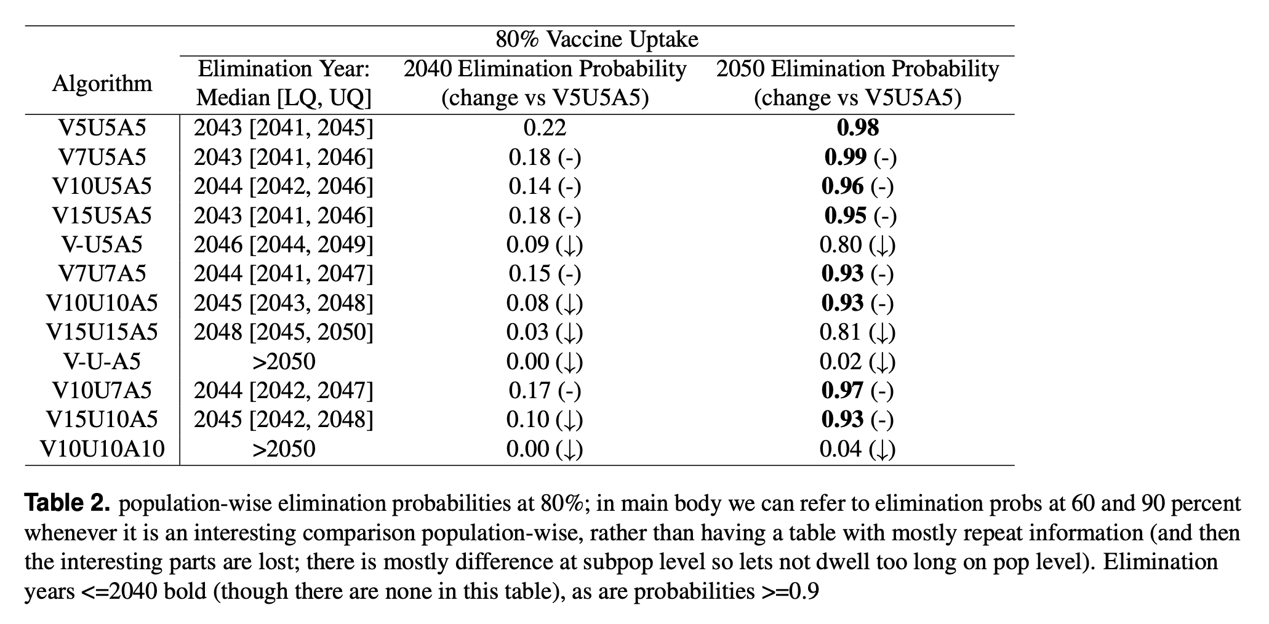
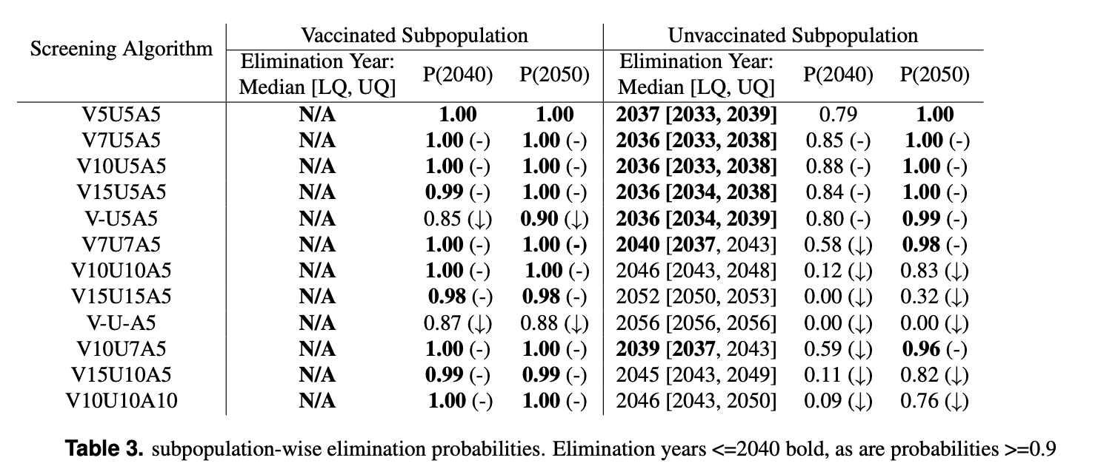

Discussion points from which the abstracts conclusions are derived
[to be added]

Comparing our results + discussion points to literature
[to be added]

Limitations
[to be added]

